**Assignment 14**

**KD1-Indrajeet-86641**

Q1. Write a command that puts the following values, in their given order, into the salespeople table: city – San Jose, name – Blanco, comm – NULL, cnum – 1100.

🡺 **insert into salespeople(city, sname, comm, snum)**

**values(‘San Jose’, ‘Blanco’, null, 1100);**



2) Write a command that removes all orders from customer Clemens from the Orders table.

🡺 **delete from orders where cnum in (select cnum from customers**

**where cname='Clemens');**

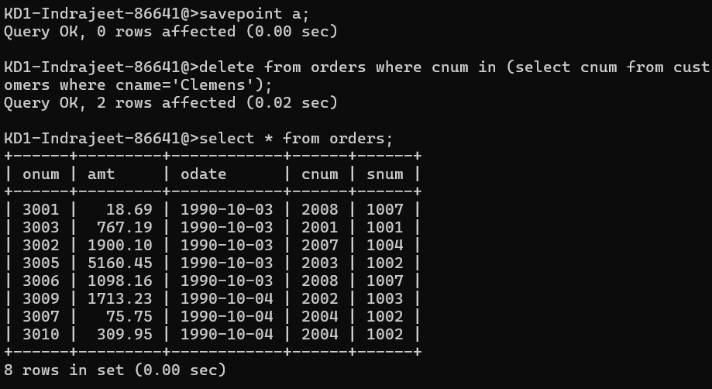

3) Write a command that increases the rating of all customers in Rome by 100.

🡺 **update customers set rating = rating + 100 where city = 'rome';**

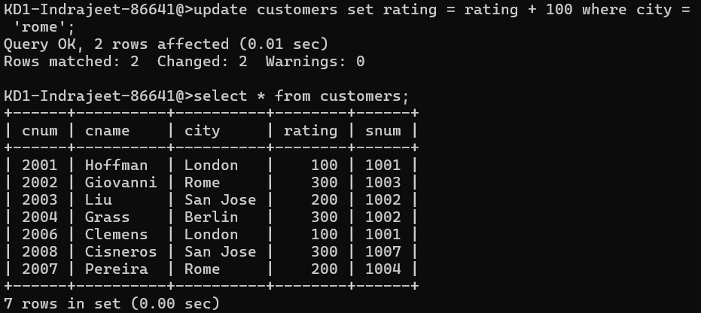

4) Salesperson Serres has left the company. Assign her customers to Motika.

🡺 **update customers set snum= (select snum from salespeople where sname='serres') where snum = (select snum from salespeople where sname='motika');**

**Output is on next page**

